**OUTLIER DETECTION IN ELECTION DATA USING GEOSPATIAL ANALYSIS**

***Case Study: Ensuring Election Integrity***

## **Introduction**

This report outlines key discoveries from a study that spotted unusual patterns in voting information through geographic grouping of poll sites. The research zeroes in on a chosen set of data, employing location details to cluster voting stations by nearness and figuring out oddity ratings for each political group.

## **Methodology**

### **Data Source**

* **Dataset:** The dataset consists of polling unit details including addresses, latitude, longitude, and votes for parties APC, LP, PDP, and NNPP.

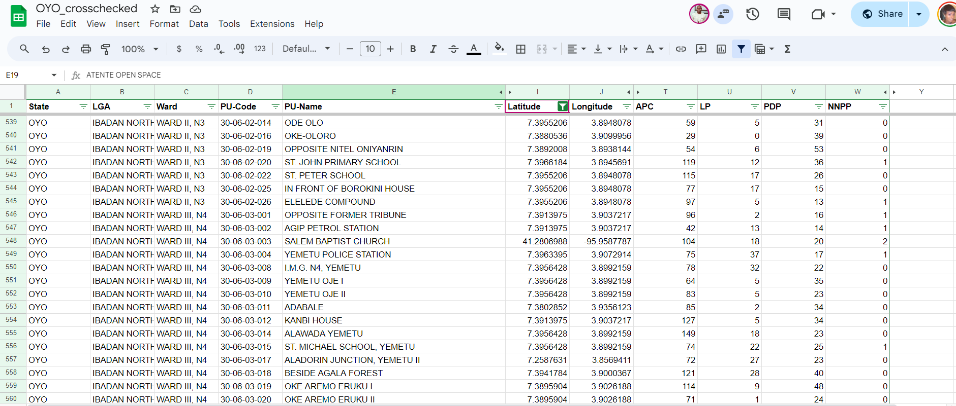

### 

### **Analysis Steps**

**Geospatial Clustering:**

* Polling units were clustered based on a proximity radius of 1 km.
* Distance matrices were computed using the scipy.spatial library to facilitate clustering.

**Outlier Score Calculation:**

* Outlier scores were computed for each party (APC, LP, PDP, NNPP) within each cluster.
* Scores were based on the deviation of votes from neighboring polling units within the same cluster.

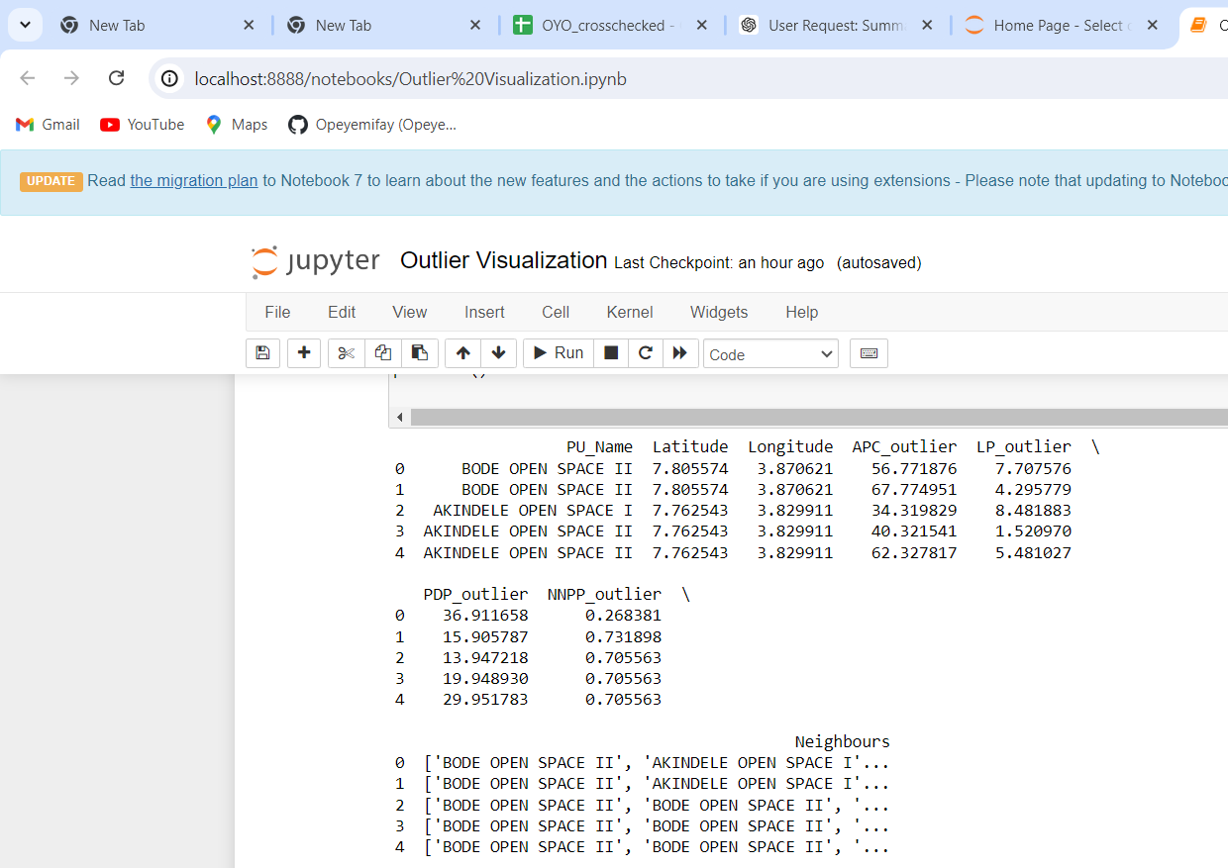

**Identification of Outliers:**

* The top 3 outliers for each party were identified based on the highest outlier scores.

## 

## **Results**

### **Top 3 Outliers for Each Party**

### **APC Outliers:**

1. **Primary School, Idi Oro Elewa**
   * Latitude: 7.451059, Longitude: 3.875394
   * Outlier Score: 333.372239
2. **I.D.C. Primary School, Awotan**
   * Latitude: 7.474601, Longitude: 3.785699
   * Outlier Score: 300.891194
3. **Oluwo Village**
   * Latitude: 7.379596, Longitude: 3.967468
   * Outlier Score: 263.407615

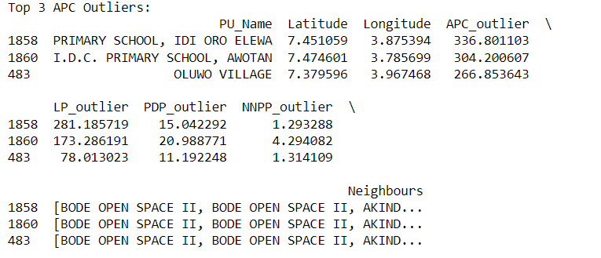

### 

### 

### 

### 

### **LP Outliers:**

1. **Queen's Hall, U.I.**
   * Latitude: 7.440982, Longitude: 3.906651
   * Outlier Score: 324.064671
2. **Community Primary School, Karamo**
   * Latitude: 8.682896, Longitude: 4.028678
   * Outlier Score: 314.521160
3. **Primary School, Idi Oro Elewa**
   * Latitude: 7.451059, Longitude: 3.875394
   * Outlier Score: 282.029823

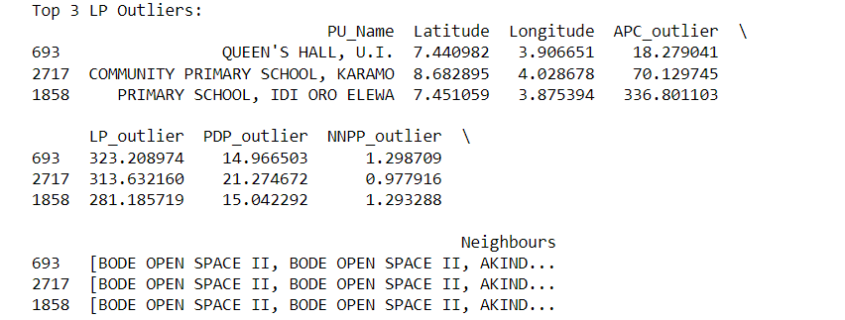

### 

### 

### 

### **PDP Outliers:**

1. **Iwo-Ate Isale**
   * Latitude: 7.845079, Longitude: 4.106290
   * Outlier Score: 248.744429
2. **Akintekun Compound**
   * Latitude: 8.090186, Longitude: 3.346448
   * Outlier Score: 165.265997
3. **L.A. School, Kajola**
   * Latitude: 8.090186, Longitude: 3.346448
   * Outlier Score: 165.265997

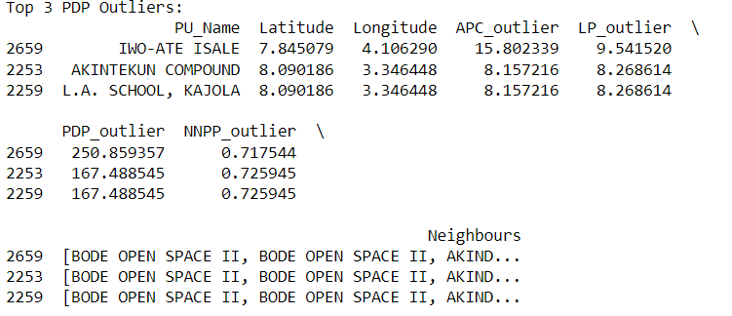

### 

### 

### 

### **NNPP Outliers:**

1. **Community Primary School, Tesi Apata**
   * Latitude: 8.787087, Longitude: 4.044853
   * Outlier Score: 121.176626
2. **Baptist Central School**
   * Latitude: 8.844786, Longitude: 3.755948
   * Outlier Score: 81.147448
3. **Beside Babasale Compound, Ilua**
   * Latitude: 8.001165, Longitude: 3.408202
   * Outlier Score: 76.333225

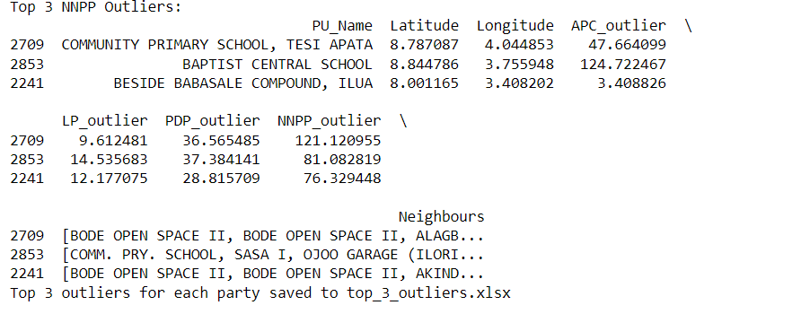

## 

## **Scatter plot of the Top 3 Outliers of each Party**

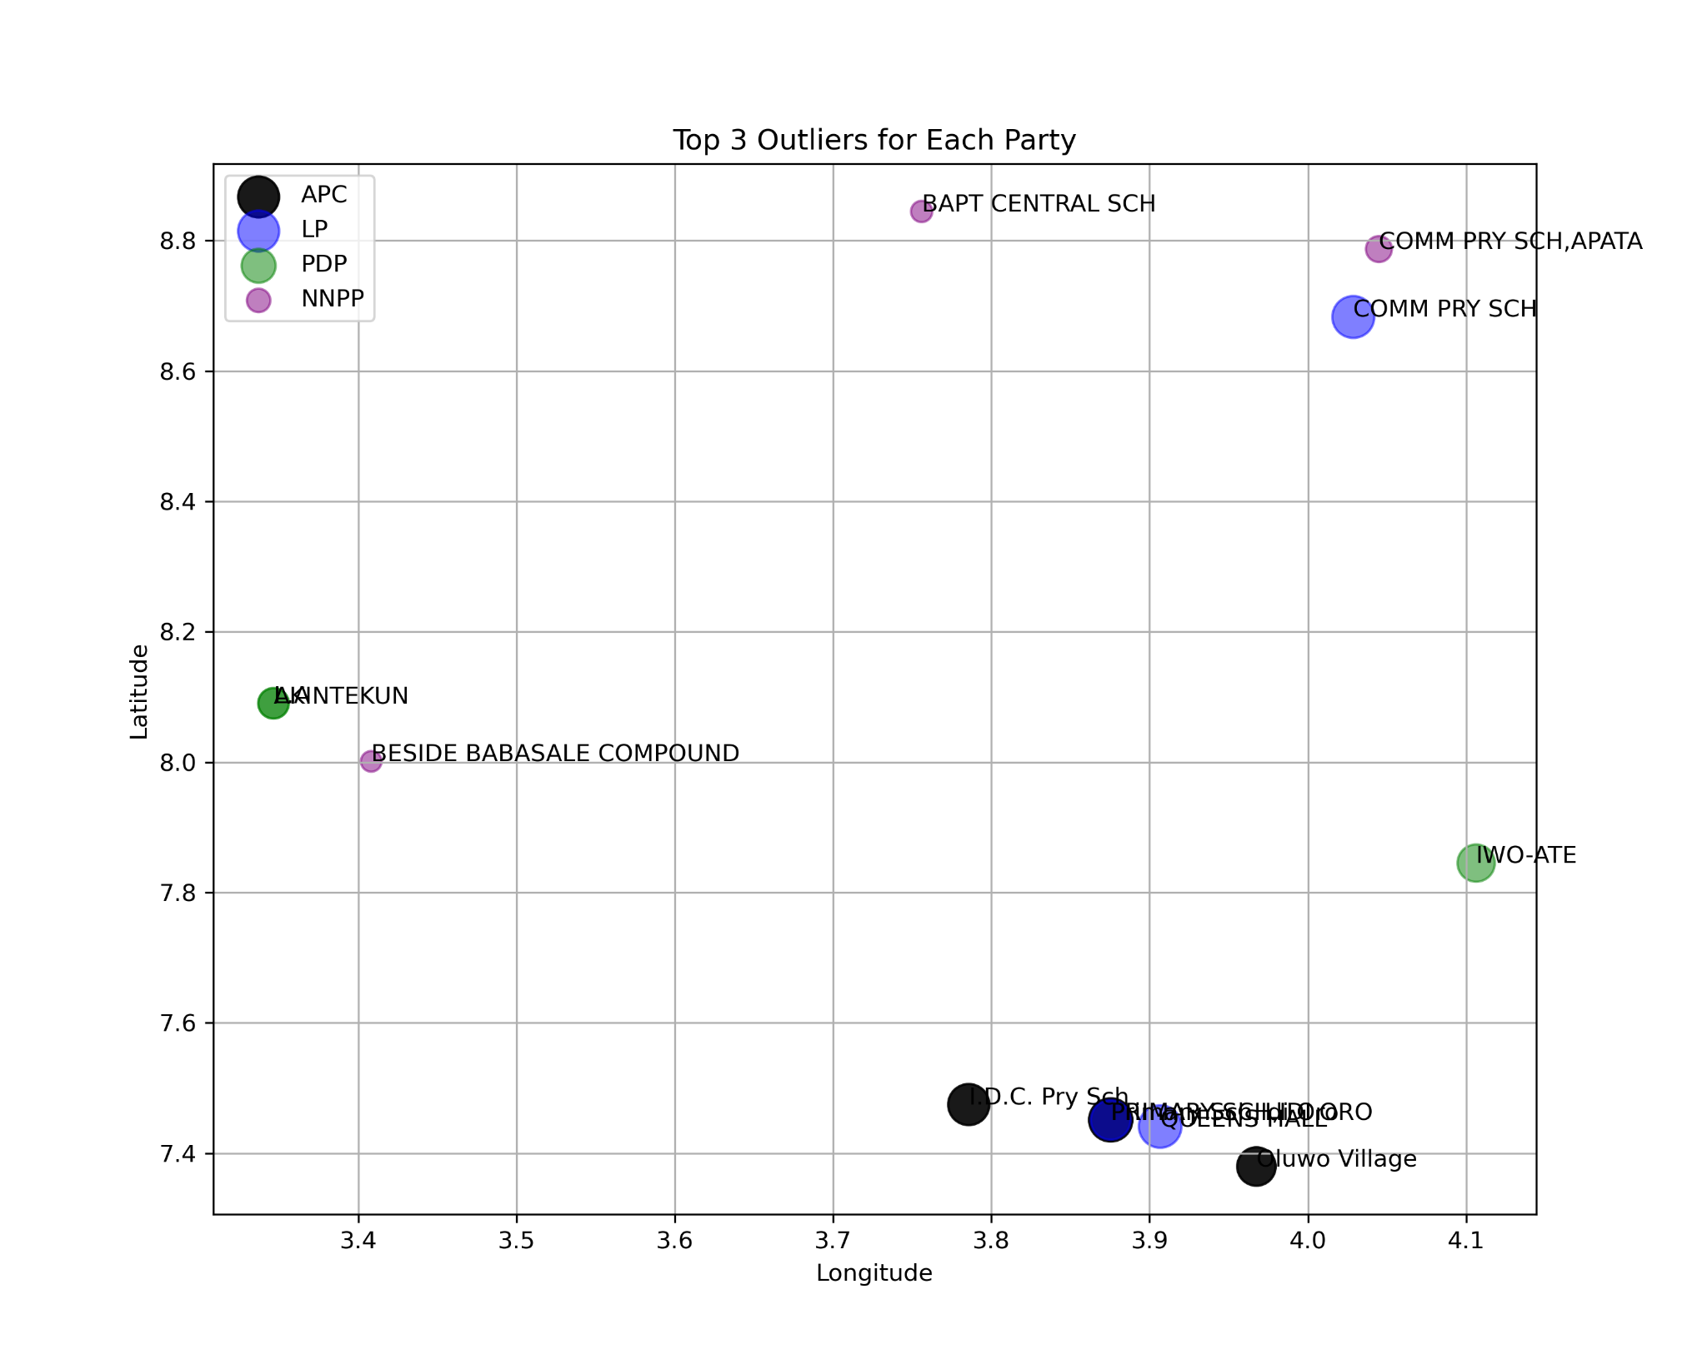

## 

## **Map Visualization**

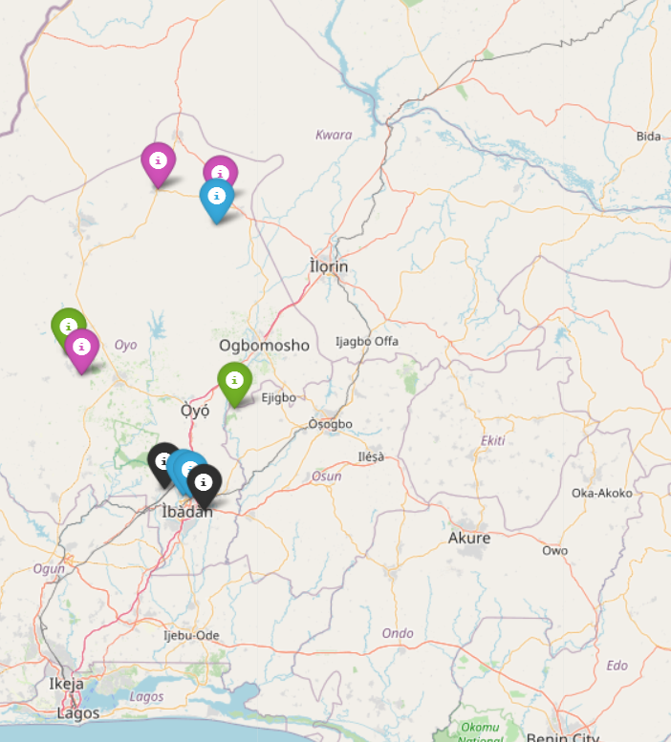

file:///C:/Users/Admin/outliers_map.html

## 

## **Conclusion**

The study found notable outliers in the election data through geospatial clustering and figuring out outlier scores. These outliers could show places with different voting habits or possible patterns or potential irregularities that need further investigation. Using a geospatial approach provided insights into localized variations in voting behavior, where parties unexpectedly got an unexpectedly more or a lot fewer votes than those nearby.

BY: Opeyemi Fayipe

opeyemifayipe@gmail.com